1. Create a Blog Using Blogspot Customize the theme Design and post new Article with 500 words

Welcome to SS Audios & Lighting Blog! Dive into the world of spectacular sound and lighting. Our blog is your go-to resource for industry insights, product reviews, and expert tips. Whether you're a professional or a passionate enthusiast, we're here to illuminate your journey in audio and lighting technology.

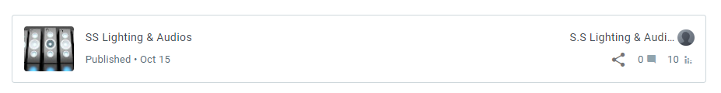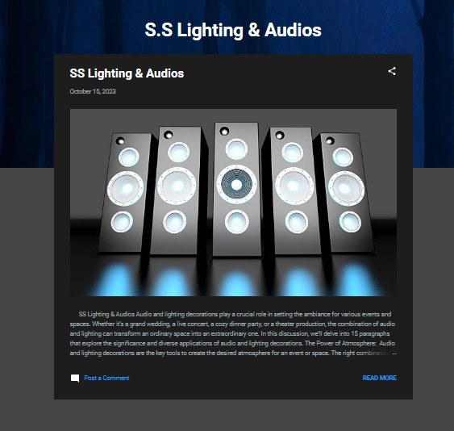

SS Audios &Lighting : <https://sslightingaudios.blogspot.com/>

1. Create a New Facebook Business Page and Post one Social media Poster for your Brand

Welcome to SS Audios & Lighting on Facebook!

We're your gateway to the world of captivating sound and lighting experiences. Stay connected for the latest updates, product highlights, and expert advice. From professional event organizers to music enthusiasts, we're here to amplify your knowledge and passion. Join our community, and let's light up the world together! #SSAudiosLighting"

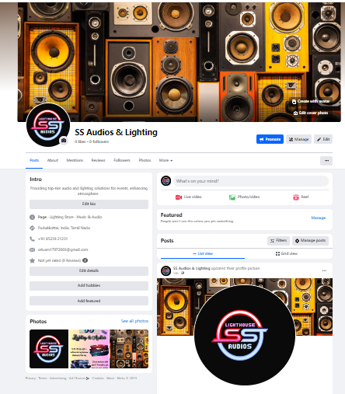

SS Audios & Lighting Facebook Page:<https://www.facebook.com/profile.php?id=61552550043467>

3.Create and Design a social media advertisement poster using Canva

Illuminate Your World with SS Audios & Lighting!

Are you ready to take your events to the next level? Discover top-notch audio and lighting solutions with SS Audios & Lighting. Elevate your experiences with our premium equipment and expert advice. Unleash the power of sound and light – Contact us today and let the magic begin! #SSAudiosLighting"

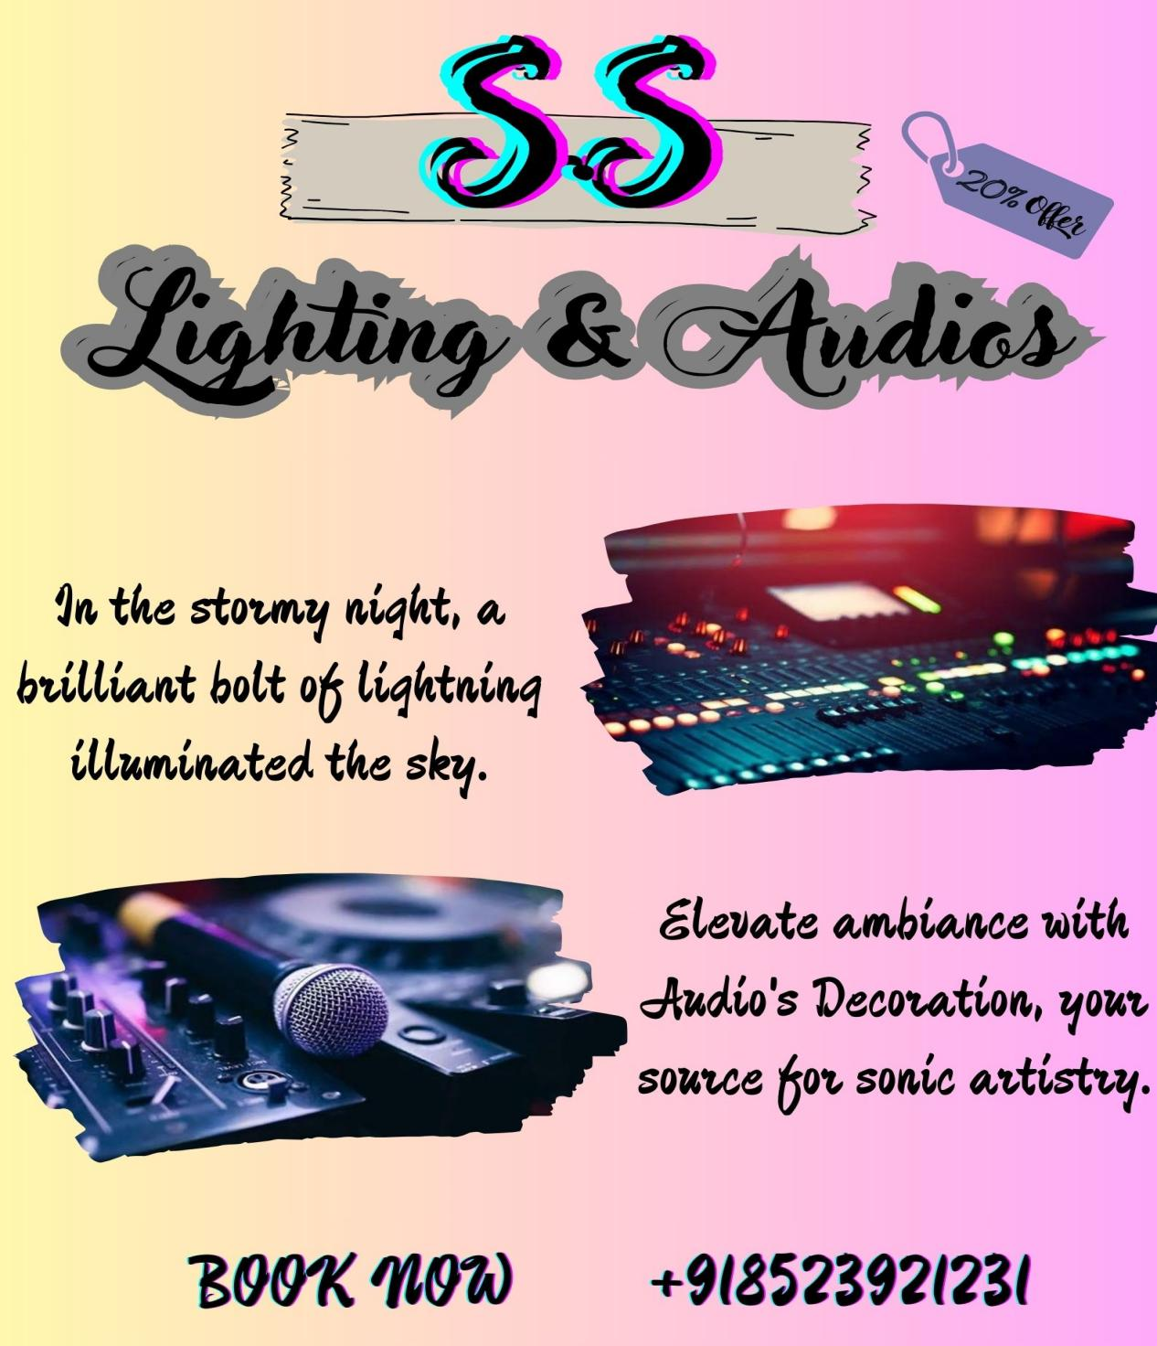

4.Create Email Newsletter Design Using Canva Tool

Unleash the power of sound and light with SS Audios & Lighting! Elevate your events to a whole new level with our premium equipment and expert guidance. From vibrant soundscapes to captivating lighting, we've got you covered. Join us in creating unforgettable moments. Contact us today for a personalized consultation and let the magic begin!

